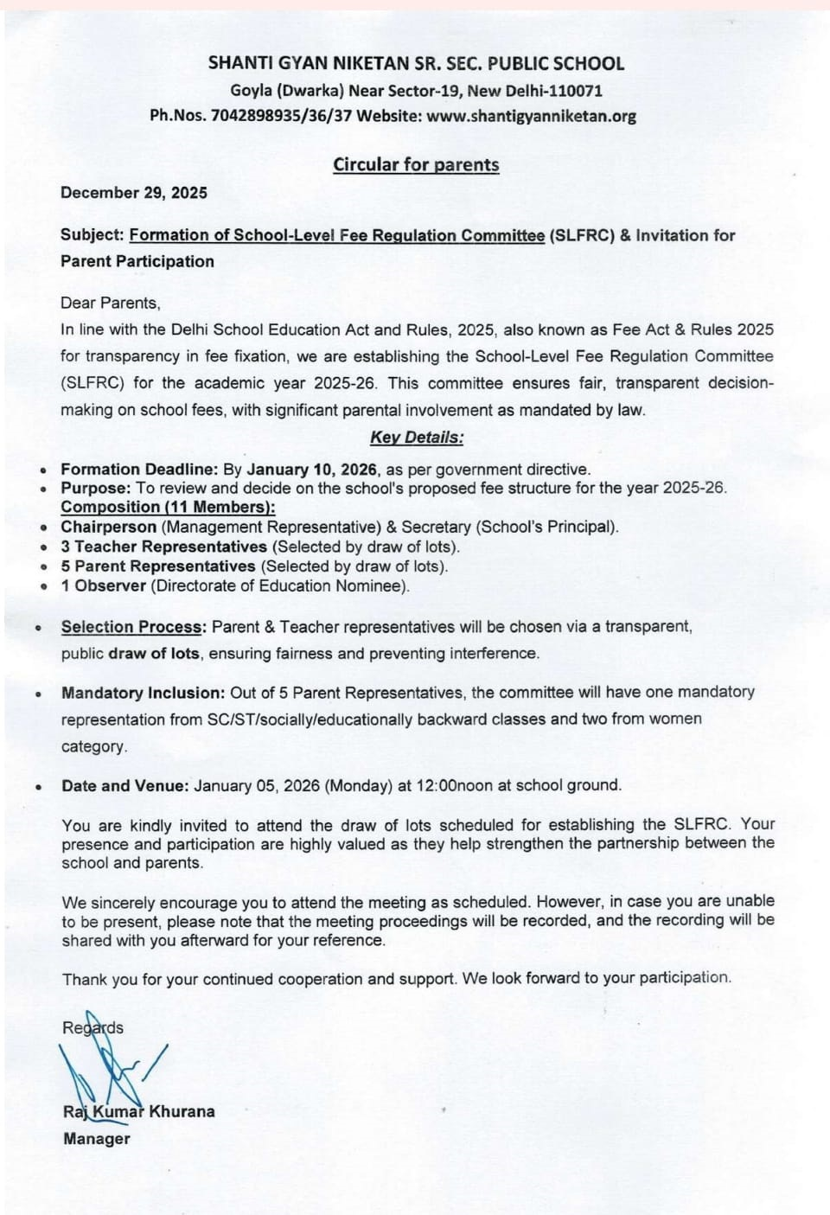
December 29, 2025
NAU UDAY CONVENT SR. SEC. SCHOOL
(D-BLOCK,PREM NAGAR, NAJAFGARH, NEW DELHI)

PH.:-9315734430, 9990092615 Website:-www.navudayconvent.in
JANUARY 08, 2026 (THURSDAY)
Regards,

PRINCIPAL

